Task No 01: Execute all example code and attach output in your lab file.

Example # 01:

Input:

using System;

namespace Abdullah_Sadiq_CP_Lab_3

{

class Program

{

static void Main(string[] args)

{

int i = 123456;

Console.WriteLine("{0:c}", i);

Console.WriteLine("{0:e}", i);

Console.WriteLine("{0:f}", i);

Console.WriteLine("{0:p}", i);

Console.WriteLine("{0:g}", i);

Console.WriteLine("{0:x}", i);

}

}

}

Output:

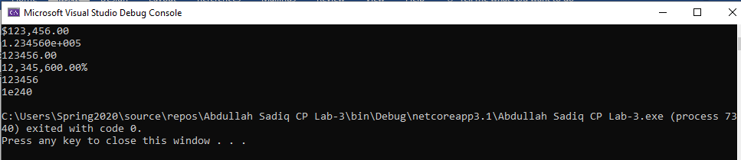

Example # 02:

Input:

using System;

namespace Abdullah_Sadiq_CP_Lab_3

{

class Program

{

static void Main(string[] args)

{

//++++Example 2

Console.WriteLine("{0:0.00}", 133.789);

Console.WriteLine("{0:0.0}", 133.789);

Console.WriteLine("{0:0.0000}", 133.789);

}

}

}

Output:

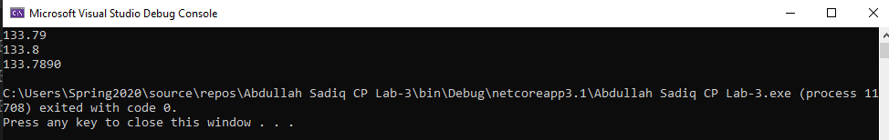

Example # 03:

Input:

using System;

namespace Abdullah_Sadiq_CP_Lab_3

{

class Program

{

static void Main(string[] args)

{

//++++Example 3

DateTime dt1 = DateTime.Now;

Console.WriteLine("{0:dd-MMM-yyyy H:mm}", dt1);

}

}

}

Output:

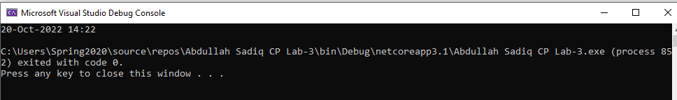

Task No 02: Create a small form which take following input from an employee of any company:

* 1. Name
  2. Father name
  3. Phone no
  4. Designation
  5. Date of hiring
  6. Salary

Using above information display user profile in a formatted manner.

Input:

using System;

namespace Abdullah_Sadiq_CP_Lab_3

{

class Program

{

static void Main(string[] args)

{

Console.WriteLine("Enter your Name");

String name = Console.ReadLine();

Console.WriteLine("Enter your Father Name");

String fatherName = Console.ReadLine();

Console.WriteLine("Enter Your Phone No");

string phoneNo = Console.ReadLine();

Console.WriteLine("Enter Your Designation");

string designation = Console.ReadLine();

Console.WriteLine("Enter your Date of Hiring");

String dateOfHiring = Console.ReadLine();

Console.WriteLine("Enter your salary");

String salary = Console.ReadLine();

Console.WriteLine("|\tName: {0}\t\t\t|\n|\tFather Name: {1}\t\t|\n|\tPhone No: {2}\t\t|\n|\tDesignation: {3}\t|\n|\tDate of Hiring: {4}\t|\n|\tSalary: {5}\t\t\t|", name, fatherName, phoneNo, designation, dateOfHiring, salary);

}

}

}

Output:

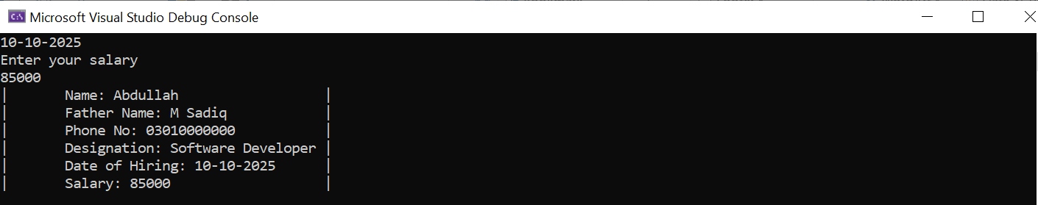

Task No 03: Create a simple C# program in which you will display the restaurant payment bill in formatted manner.

Input:

using System;

namespace Abdullah_sadiq_Lab_03

{

class Program

{

static void Main(string[] args)

{

Console.WriteLine("\tTaste a Bite\n\tHaroon Bahria Society Karachi\n\n");

DateTime dt1 = DateTime.Now;

Console.WriteLine("{0:\t\tMM/dd/yy h:mm:ss tt}", dt1);

Console.WriteLine("-------------------------------------");

Console.WriteLine("Table: 201 Chk: #1111 Guest: 2");

Console.WriteLine("-------------------------------------\n\n");

Console.WriteLine("\t 1 Zinger Burger{0,-2:C}", 5.3);

Console.WriteLine("\t 2 Paratha Rolls{0,-2:C}\n\n", 8.3);

Console.WriteLine("\t Subtotal{0,-2:C}", 13.6);

Console.WriteLine("\t Tax{0,-2:C}", 3.3);

Console.WriteLine("\t Gratuity{0,-2:C}", 2.3);

Console.WriteLine("\t Total Due{0,-2:C}\n\n\n", 19.3);

Console.WriteLine("\t Thank you For Dining With Us!\n\t\tPlease Come Again");

}

}

}

Output:

